1) Birth and Life of a Star
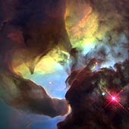
Stars are born in enormous cloud of gas (mainly Hydrogen and Helium) and dust many light-years across. Gravity pulls the materials together. Compressing the gas and dust into a giant ball that, at it’s centre temperatures are 15 million degrees or so (created by all gas and dust bumping into each other under the great pressure of the surrounding material). The pressure at the centre of the ball becomes so enormous that the nuclei crash into each other so hard that they stick together, or fuse. In doing so, they give off a great deal of energy in the form of Heat and Light. This reaction is called nuclear fusion
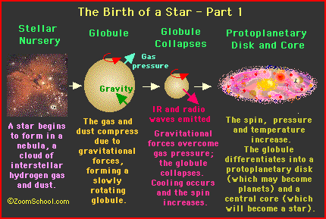
New stars come in a variety of sizes and colours. They range from blue to red, and from less than half the size of our Sun to over 20 times the Sun’s size. It all depends on how much gas and dust is collected during the star's formation. The colour of the star depends on the surface temperature of the star. And its temperature depends; again, on how much gas and dust were accumulated during formation. The more mass a star starts out with, the brighter and hotter it will be. For a star, everything depends on its mass.
2) The Beginning of the End
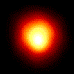
After millions to billions of years, (depending on their masses), stars run out of their main fuel - hydrogen. Once the ready supply of hydrogen in the core is gone, nuclear processes occurring there cease. As a result, the outer layers of the star are pushed outward. The star expands to larger than it ever was during its lifetime (up to a hundred times bigger). The star has become a red giant.
What happens next in the life of a star depends on its initial mass.

3) THE DEATH OF SUN-LIKE STARS
(with a mass up to 1 1/2 times that of the Sun)
Once a medium size star (such as our Sun) has reached the red giant phase, its outer layers continue to expand, but it’s core contracts, the result being that helium atoms together to form carbon. This fusion releases new energy but only for a few minutes! The core is now stable and the end is near.
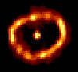
The star now loses its outer layers as a cloud (called a planetary nebula). Meanwhile the core of the star spends the rest of its days cooling and shrinking until it is only a few thousand miles in diameter. It has become a white dwarf. With no fuel left to burn, the hot star radiates its remaining heat into the coldness of space for many billions of years. In the end, it will just sit in space as a cold dark mass sometimes referred to as a black dwarf. 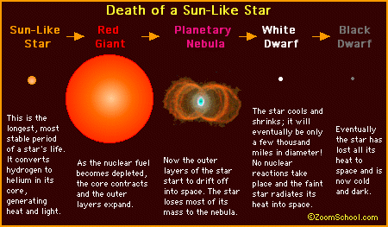
4) THE DEATH OF HUGE STARS
(from 1.5 to 3 times the mass of the Sun)
After the outer layers of the star have swollen into a red supergiant (i.e., a very big red giant), the core begins to shrink. As it shrinks, it grows hotter and denser, and a new series of nuclear reactions take place, as new and heavier elements are formed by fusion. However, when the core becomes essentially just iron, it has nothing left to fuse (because of iron's nuclear structure, it does not permit its atoms to fuse into heavier elements) and fusion ceases. In less than a second, the star begins the final phase of its gravitational collapse. The core temperature rises to over 100 billion degrees as the iron atoms are crushed together. The repulsive force between the nuclei overcomes the force of gravity, and the core recoils out from the heart of the star in an explosive shock wave.. In one of the most spectacular events in the Universe, the shock propels the material away from the star in a tremendous explosion called a supernova. The material spews off into space

So what, remains of the core of the original star? The whole core of the star becomes nothing but a dense ball of neutrons. It is possible that this core will remain intact after the supernova, and be called a neutron star. However, if the original star was very massive (say 15 or more times the mass of our Sun), even the neutrons will not be able to survive the core collapse and a black hole will form!
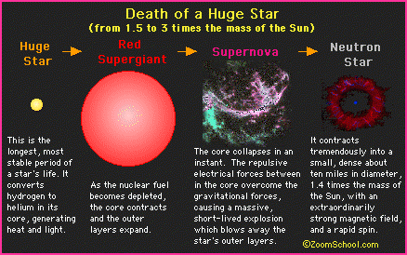
5) IN SUMMARY
