RED SHIFT THEORY

This is the theory that explains how the stars are all moving apart and thus is evidence for an “expanding universe theory

1) How Moving Objects Affect the Frequency of Waves
To understand how it works you first need to understand how moving objects can affect the frequency of a wave
Imagine the sensor on the front of this boat counts the number of water waves that hit it every second
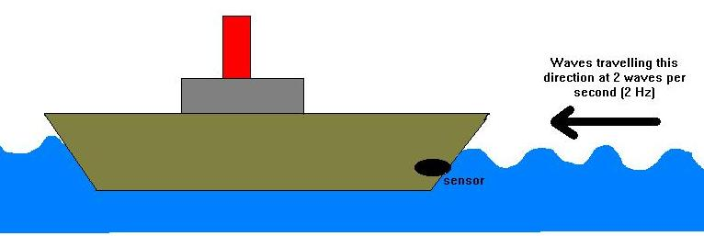
- If the boat is anchored (not moving) 2 waves per second will hit the boat (the frequency will be 2Hz)
- If the boat is moving RIGHT MORE waves will hit the boat every second (The Frequency will INCREASE)
- If the boat is moving LEFT LESS waves will hit the sensor every second (the Frequency will DECREASE)

2) The Doppler effect
Applying this theory to sound we get the Doppler effect
For Sound
- High frequency = High Pitch
- Low Frequency = Low Pitch
a) Imagine you are standing between the two houses in the diagram below. The ambulance is standing still and switches it’s siren on. The frequency is 12Khz
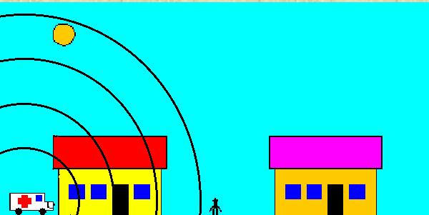

b) The Ambulance Moves towards you c) The Ambulance moves away from you
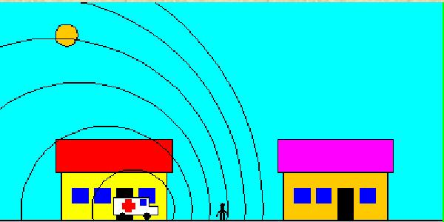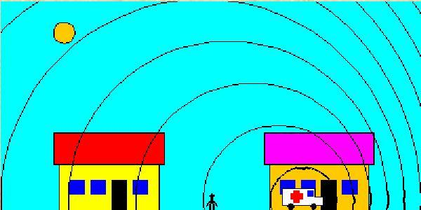
By moving towards you, the siren effectively squashes up the sound waves in front of it. This increases the frequency of the sound wave you hear. This means that the Siren now sounds higher pitched
By moving away from you, the siren effectively pulls the sound waves apart this decreases the frequency of the sound waves you hear. This means that the Siren now sounds higher pitched

3) RED SHIFT
Now apply the same theory to light

For Light

High Freq
Low Freq
In other words, the light spectrum has frequencies as follows
Low freq High Freq

a) Imagine a Star (like our sun) standing still emitting light you would see it as it is (yellow)
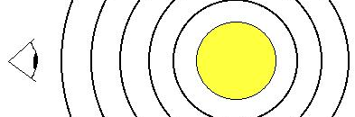

b) Blue Shift c) Red Shift
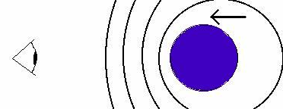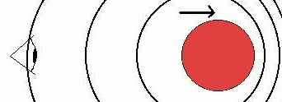
If the Star is moving towards you the light waves squash together. The frequency increases so the star appears to your eye bluer than it really is.
If the Star is moving away from you the light waves are pulled apart. The frequency decreases so the star appears to your eye redder than it really is.

