THE BIG BANG THEORY - SOURCE 2
Fifteen billion years ago, the entirety of our universe was compressed into the confines of an atomic nucleus. Known as a singularity, this is the moment before creation when space and time did not exist. According to the some Scientists this singularity exploded, creating temperature trillions of degrees (on any measurement scale), and subsequently created subatomic particles and thus matter and energy and space and time itself. These events have become known as known as the big bang.
Quantum theory suggests that moments after the Big bang (10⁻⁴³ second), the four forces of nature; strong nuclear, weak nuclear, electromagnetic and gravity were combined into a single "super force"(Wald).

In addition, Elementary particles known as quarks begin to bond into threes, forming photons, positrons and neutrinos (as well as anti-photons, anti-positrons and anti-neutrinos- known as antiparticles). Particle and antiparticle collided and annihilated each other causing a release of more energy. Since Particles outnumbered anti particles, the remaining particles constitute the majority of our universe today during this time the universe was undergoing a rate of expansion many times the speed of light. The universe in less than one thousandth of a second doubled in size at least one hundred times,
When the universe aged to one hundredth of a second old neutrons begin to decay on a massive scale. This allowed for free electrons and protons to combine with other particles. Eventually the remaining neutrons would combine with protons to form heavy hydrogen (deuterium). the temperature has now dropped to a mere 1013K with the Strong Nuclear, Weak Nuclear and Electromagnetic interactions now separated and able to exert their force.
As the gas cloud (universe) expands one full second after the initial explosion and the temperature of our Universe has dropped to ten billion degrees,
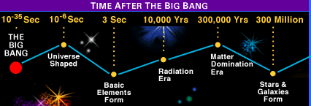
After three minutes and a temperature of one billion degrees, protons and neutrons were slowing down enough in order to allow nucleosynthesis to take place. Atomic nuclei of helium were produced as two protons and neutrons each bonded. For every helium nuclei formed there were about ten protons left over allowing for twenty-five percent of the Universe to be comprised of helium nuclei. However, very few atoms were actually formed and radiation is still the dominant feature.
For the next 300,000 years The universe continues to expand and cool to a temperature of 10,000°K. After this time conditions were right for helium nuclei to absorb free-floating electrons and become helium atoms. In addition, hydrogen atoms were bonding together to form lithium. It is here that the density of the universe has expanded to the point where light can be perceived. It is the beginning of the Matter Domination Era
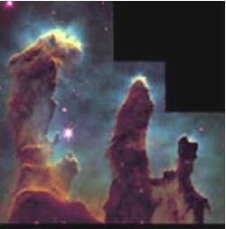
300 Million Years after the big bang the universe is still expanding rapidly, pockets of gas become more and more dense. Within these pockets, Stars are born and and form groups of stars which become the earliest galaxies. The Hubble Space Telescope recently captured some of the earliest galaxies ever viewed. They appear as tiny blue dots.

Proving the Big Bang Theory
1) During the 1890's the Lick Observatory in California used “red-shift” theory to track and chart the radial velocity of many stars, and planetary nebulae. Several astronomers, among them Edwin Hubble, noticed a correlation between the distance of these galaxies and their velocities. The proof was conclusive: the further away a galaxy was relative to the Earth, the greater the velocity of that galaxy. Hubble had irrefutable proof that the Universe was expanding. (Weinberg).
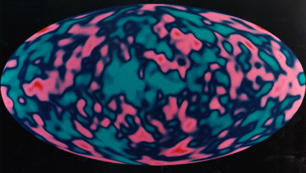
2) Astronomers use the new Cosmic Background Explorer satellite (COBE) to take a detailed spectrum of the microwave background radiation. These studies showed that the radiation is in nearly perfect agreement with the Big Bang theory.

3) In addition Atomic theory (splitting and studying the atom)has helped us to understand the conditions (pressures and temperatures) needed to form different particles.

4) Studies of radio waves picked up from space (collected by radio telescopes looking for other life forms) are similar to those emitted during explosions. These indicate a VERY large explosion somewhere between 12 and 15 billion years ago

