REVISION PD3-FORCES AND MOTION

1) A car travels at 70mph what exactly does this mean?

2) Calculate the speed of a car that travels 50Km in 30minutes
Explain why the velocity of the car could be 0Km/h.

3) Describe an experiment to measure the speed of a trolley in a laboratory.

4) A Trolley rolling down a ramp has a piece of ticker tape connected to it. As it rolls down the ramp the tape is pulled through a ticker timer. The timer puts 50 dots onto the tape every second,
a) What do the following pieces of ticker tape tell us about the movement of the trolley?
b) Calculate the speed of the object attached to tape B

5) Calculate the acceleration of a car that takes 10 seconds to reach 100km/h (from rest)

6) What force is required to move a car of mass 500kg if the force due to friction is 1N?

7) An aeroplane of mass 10,000Kg has a force of 100,000N applied to it what is it’s acceleration?

8) A Force of 2N acts on a trolley of mass 1000g
a) Calculate the acceleration (in m/s²)
b) The Velocity after 20 seconds
c) The distance moved in m?

10) Using the following data,

Distance(m) | 0 | 1 | 3 | 6 | 10 | 14 | 18 | 22 | 22 | 22
Time(secs) | 0 | 5 | 10 | 15 | 20 | 25 | 30 | 35 | 40 | 45

a) Plot a graph of these results
b) How far did the object travel?
c) At what speed was the object travelling after 20 seconds?
- Describe the motion of the object (include details of speed acceleration and distance)

11) A train has a speed of 60 km/h. It’s speed 5 seconds later is 70Km/h
- what is the acceleration in m/s?
- What will it’s speed be after another 2 seconds if the acceleration remains the same?
- How long will it take to reach 105km/h at this acceleration?

12) A young girl falls in the road. A driver travelling at 30 mph (13m/s) spots the girl immediately. He is 25 meters away
- Calculate the drivers THINKING DISTANCE if his reaction time is 0.5 of a second
- Calculate the stopping distance if the Braking distance is 14m
- Will the driver hit the girl?
- How would the drivers stopping distance be affected if it was raining?

13)
- Which WAY do each of the objects move?
- Which Object has the quickest acceleration?
- If each object has a mass of 10kg what is the acceleration of each object?

14)
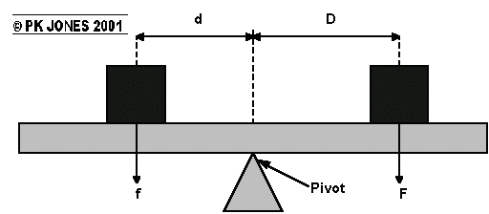

a) If the Clock wise turning force was 50Nm and a weight of 10N was placed on the other side of the see-saw. How far would it have to be from the pivot in order for the seesaw to balance?
b) calculate the 2 missing values
f | d | F | D
20N | 5m | ? | 2m
5N | ? | 30N | 3m

15

