Y11 REVISION PD6 EARTH SPACE AND RADAITION

1) Explain (with the aid of a diagram)
a) Why the earth has night and day
b) Why the earth has seasons

2) Name (in order of distance from the sun) the nine planets in our solar system.
a) Which is the biggest b) Which is the smallest c) Which is the hottest
d) Which is the coldest e) Which has the most moons

3) How long does it take for the moon to complete 1 orbit of the earth
Draw a diagram to show how and when the moon appears as a new moon half moon and full moon

4) What is happening in these two diagrams?
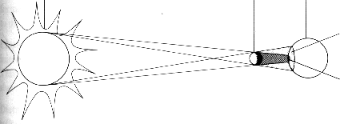
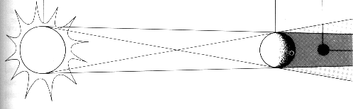
5) A new planet is discovered. you are given the responsibility of investigating whether the planet is fit for humans to live on. What things will you need to know, in order to say whether the planet is fit for human to live on.

6)
a) What is a light year?
b) How fast does light travel?
c) How far is it to the nearest star?
d) What is the name of the nearest star?
e) What is the name of our galaxy?
f) what is the name of the closest galaxy

7) Explain what is meant by “Red Shift”? What does it enable us to find out?

8) Name 4 things that artificial satellites can be used for

9) Using the “Big Bang Theory” explain (in simple terms) how the universe developed from the start of the universe up to present day

10) There are three possible things that might happen to the universe in the future, what are they?

11) Briefly say how a star is born and what might happen to it as it dies

